3.2.2 GUI Design

3.15. Splash Screen
Figure 3.15 presents the CrayCare Splash Screen displayed upon launching the application. It shows the crayfish logo, application name, tagline, and loading indicator while system resources initialize. After approximately three seconds, the system checks the user’s authentication status. Users who are not logged in are redirected to the Login Screen, while authenticated users proceed directly to the Dashboard.
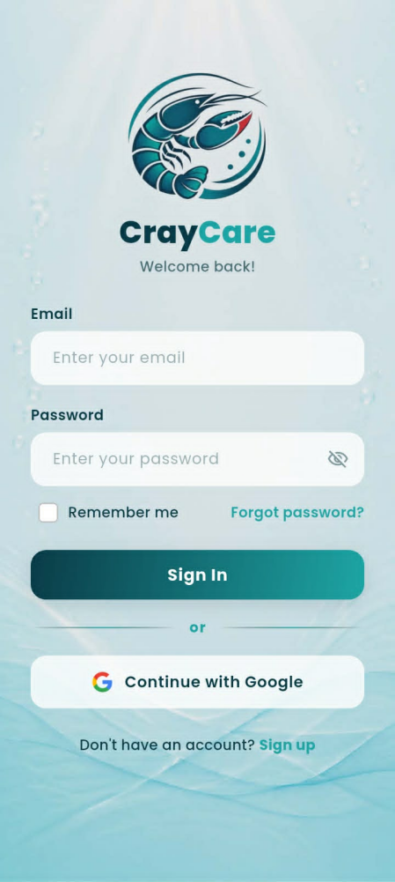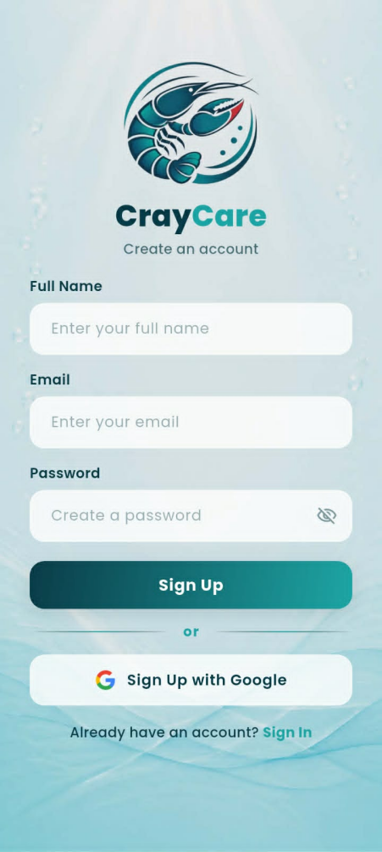
Figure 3.16. User Authentication Screens
Figure 3.16 presents the Login and Sign Up screens of the CrayCare mobile application. The Login Screen allows users to enter their email and password, remember their account, reset a forgotten password, or sign in using Google. The Sign Up Screen allows new users to register using their full name, email, and password or sign up with Google. Both screens include a password visibility toggle for easier credential verification.
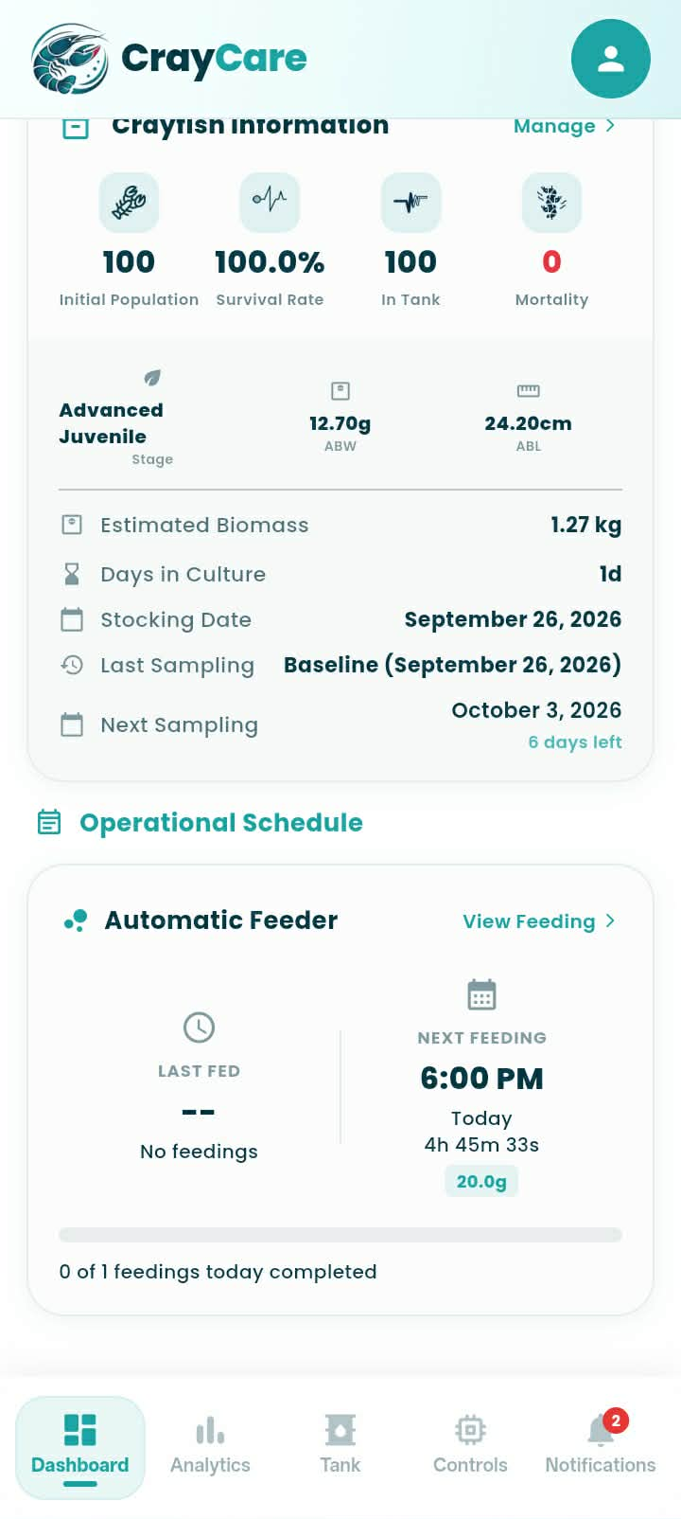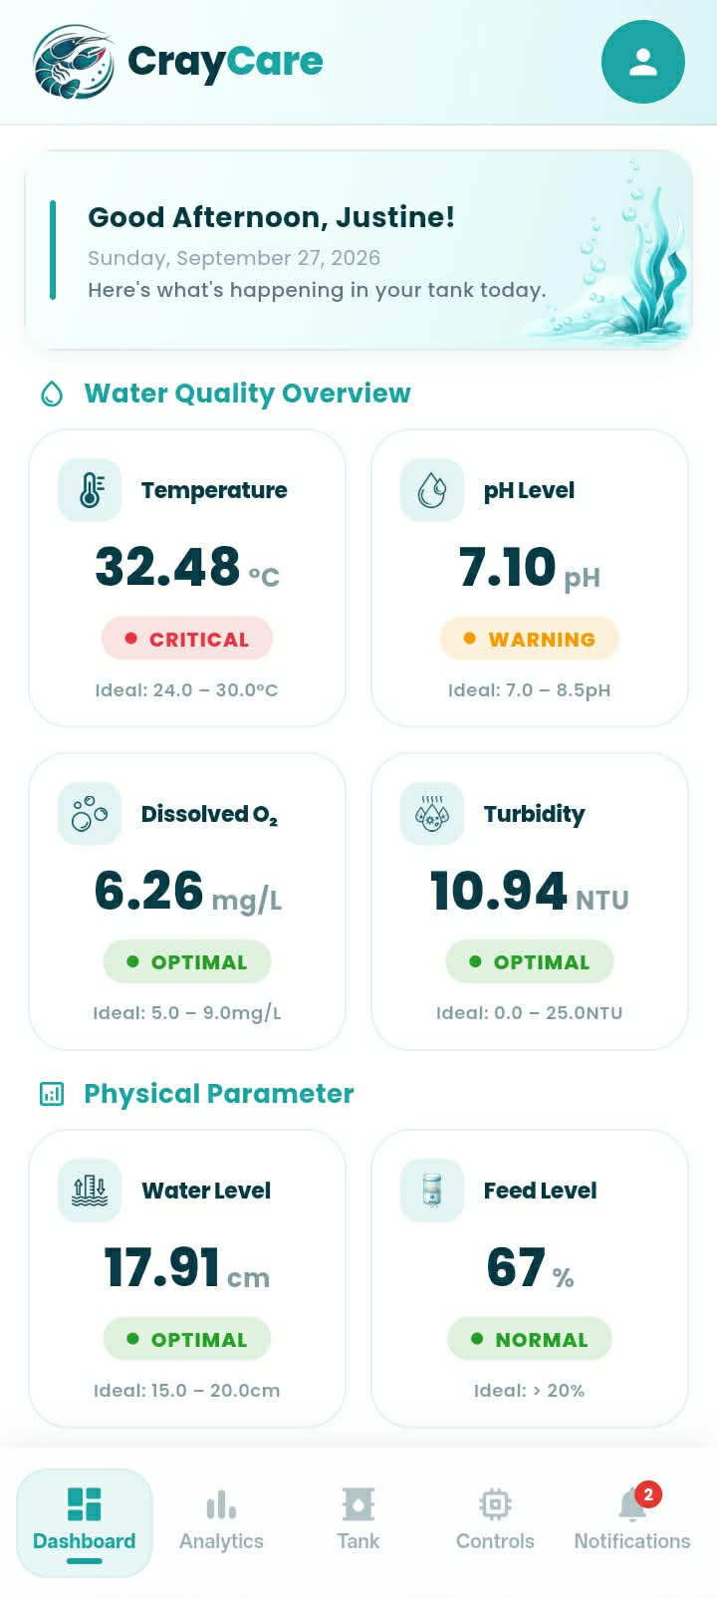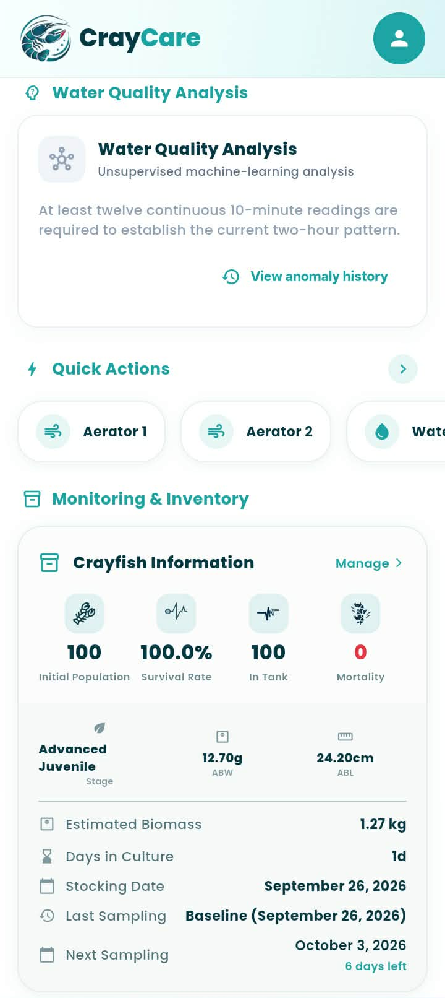
Figure 3.17. Dashboard Module Overview
Figure 3.17 displays the continuous scroll of the Dashboard Module, which serves as the main hub for real-time monitoring and tank management. It presents a personalized greeting and color-coded cards for monitoring temperature, pH, dissolved oxygen, turbidity, water level, and feed level. The dashboard also includes the Water Quality Analysis feature, which uses machine learning for water quality anomaly detection. Quick Actions and the Tank Status panel provide access to key tank information, including live population, survival rate, days in culture, and growth stage. The Operational Schedule displays feeding times, the countdown to the next feeding, and the progress of completed feeds for the day.
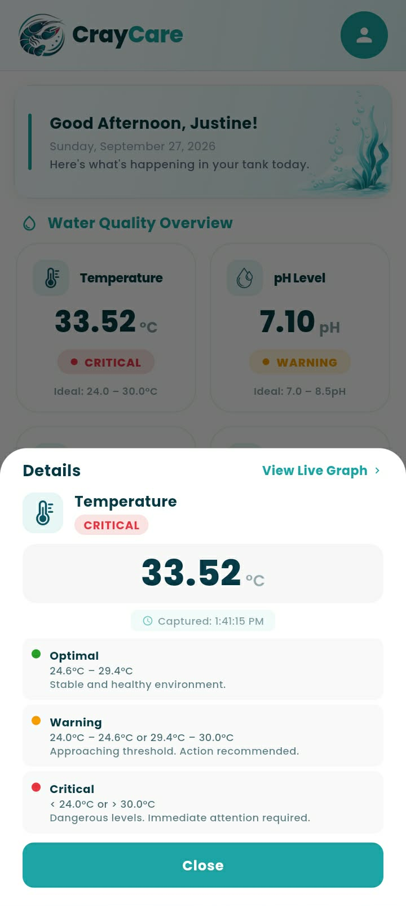
Figure 3.18. Parameter Detail Modal
Figure 3.18 presents the Parameter Detail Modal, which appears when a user selects a parameter card on the dashboard. Using Temperature as an example, the modal displays the current reading, its trend, and the capture time. It also explains the Optimal, Warning, and Critical ranges. The “View Live Graph” shortcut opens the related analytics, while the “Close” button returns the user to the dashboard.
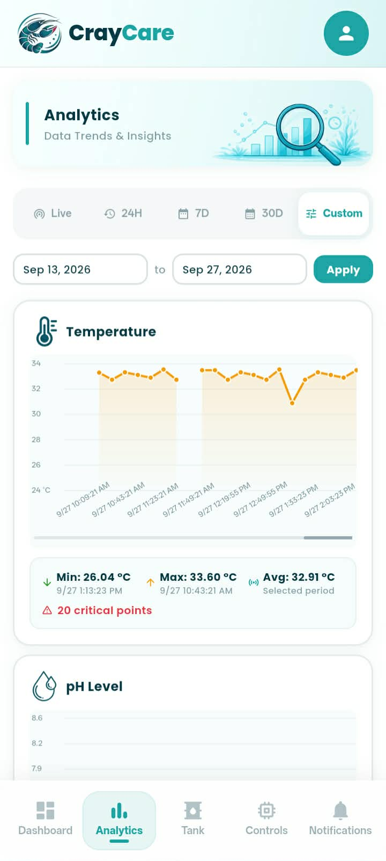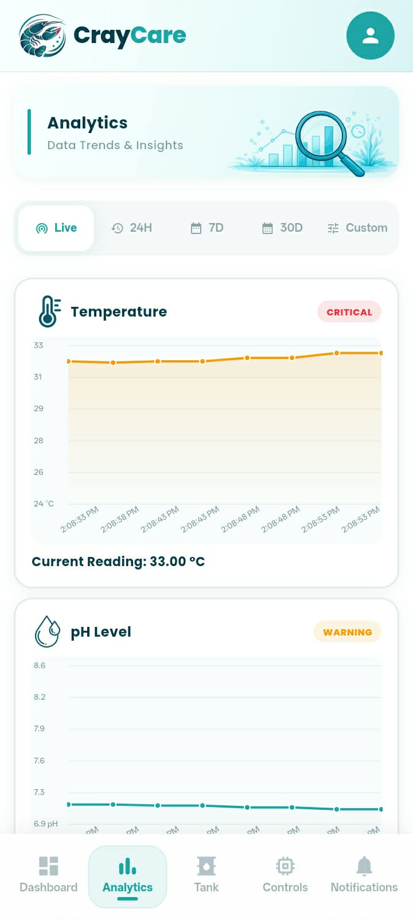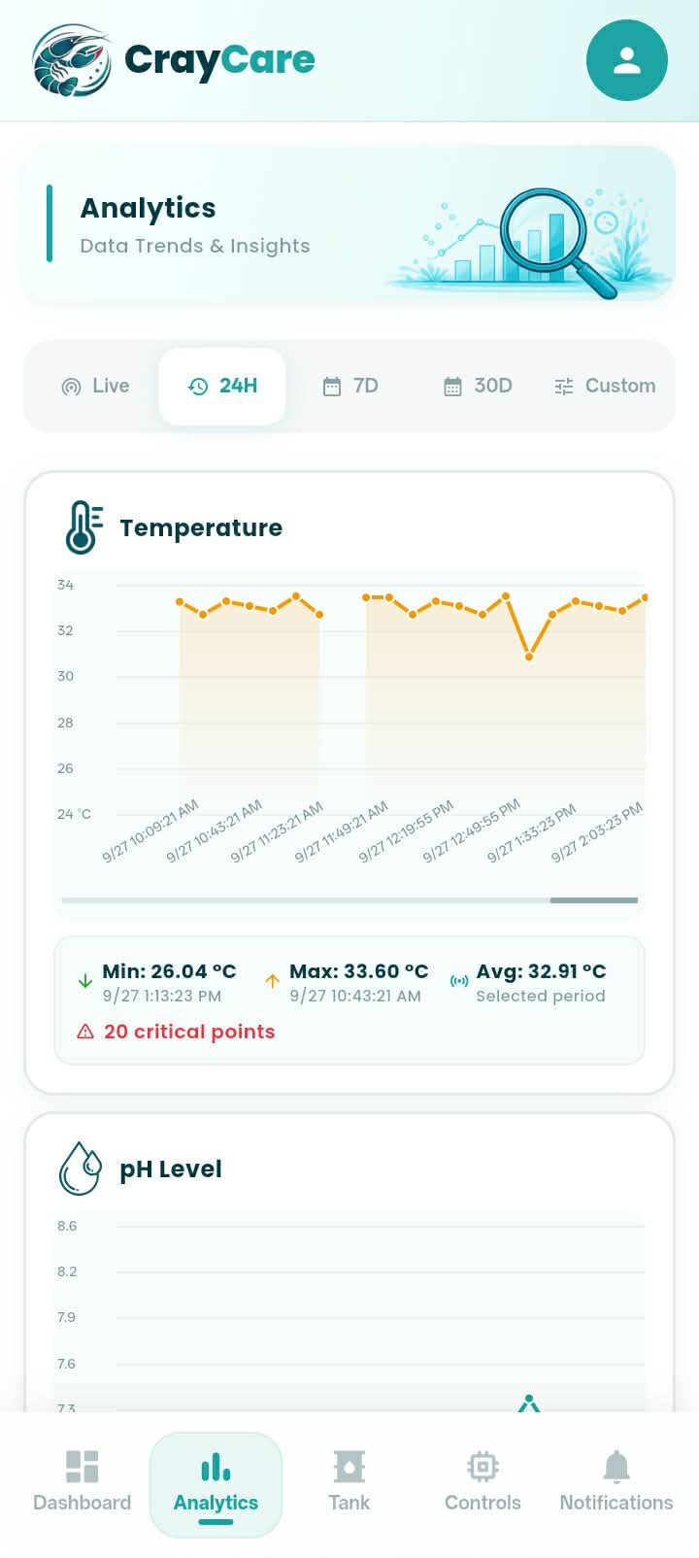
Figure 3.19. Analytics Module
Figure 3.18 presents the Analytics Module, where users can view temperature, pH, dissolved oxygen, turbidity, and water-level charts across Live, 24H, 7D, 30D, and Custom ranges. Each graph shows how sensor readings rise or fall over time and displays the parameter’s status. Live view shows the current reading and status, while the historical ranges provide minimum, maximum, and average readings and highlight critical points when present. In the Custom range, users select start and end dates. Tapping a chart opens a modal for a closer view, where tapping a data point displays its timestamp and reading.
Figure 3.22. Tank Module — Overview Tab
Figure 3.22 presents the Inventory Tab of the Tank Module in the CrayCare mobile application, which facilitates population tracking and grow-out monitoring. The upper section displays a circular donut chart indicating the current survival rate (98%) alongside a grid of six key metric cards: Initial Population, Sample Size, Initial Total Sample Weight (with computed ABW), Initial Total Sample Length (with computed ABL), and the calculated Alive and Mortality counts. Beneath the metric cards, three action buttons allow the farmer to record mortality events, edit the tank setup, or open the detailed activity logs. At the bottom, a Tank Information card aggregates timeline-critical data, including the initial stocking date, the total days in culture, and the timestamp of the last configuration edit.
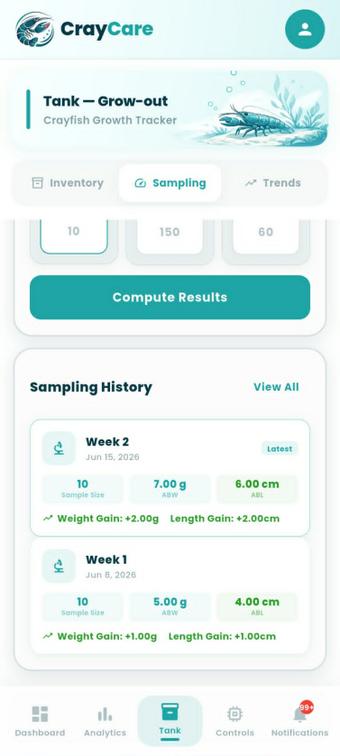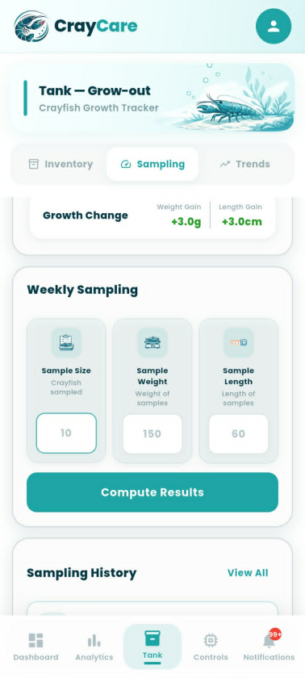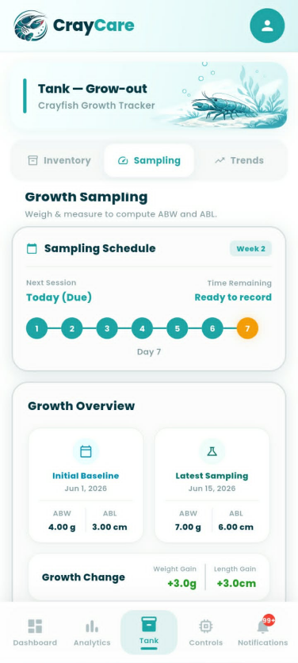
Figure 3.23. Tank Module — Sampling Tab
Figure 3.23 presents the Sampling Tab of the Tank Module in the CrayCare mobile application, which allows the user to record, calculate, and log weekly crayfish growth metrics. The upper section features a Sampling Schedule card displaying a seven-day step-tracker timeline that indicates session readiness, paired with a Growth Overview card comparing the initial baseline values to the latest sampling results to show cumulative growth changes. Below this, a Weekly Sampling entry form provides input fields for Sample Size, Sample Weight, and Sample Length alongside a prominent "Compute Results" action button to process the current batch averages. At the bottom, a Sampling History panel displays a chronological list of past logs, showcasing metrics such as sample sizes, average weights and lengths, and individual weight and length gains per week.
Growth Monitoring through Weekly Sampling of Average Body Weight (ABW) and Average Body Length (ABL)
Growth monitoring in crayfish is commonly done by measuring changes in body weight and body length. These measurements help determine the growth progress and development of crayfish during the culture period. In this study, weekly sampling was conducted to monitor the growth of Cherax quadricarinatus using Average Body Weight (ABW) and Average Body Length (ABL) as the main growth measurements.
The weekly sampling approach was based on the study of Fatihah and Chen (2022), which evaluated the growth performance of redclaw crayfish (Cherax quadricarinatus) in an aquaponics system. In their study, body weight and body length were measured regularly within a 28-day period. Measurements were taken on Day 0, Day 7, Day 14, and Day 28 to observe changes in crayfish growth.
Their findings showed that measuring body weight and body length regularly helped track the growth of crayfish throughout the experiment. After 28 days, the treatment group recorded a mean body weight of 19.93 ± 0.48 g and a mean body length of 11.13 ± 0.60 cm, which was higher compared to the control group with a mean body weight of 17.08 ± 0.53 g and a mean body length of 9.58 ± 0.17 cm. These results show that regular measurement of weight and length can be used to monitor growth changes and determine differences in crayfish development.
Based on this method, the present study adopted weekly sampling to observe changes in crayfish growth throughout the culture period. The Average Body Weight (ABW) is calculated by getting the average weight of the sampled crayfish, while the Average Body Length (ABL) is calculated by getting the average length of the sampled individuals. These measurements will serve as the basis for evaluating crayfish growth and determining if the culture conditions support their development.
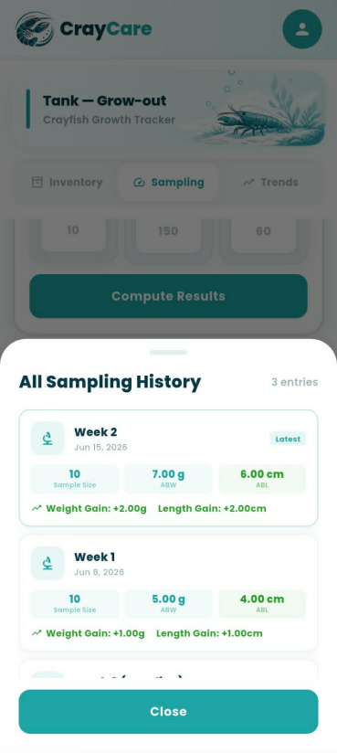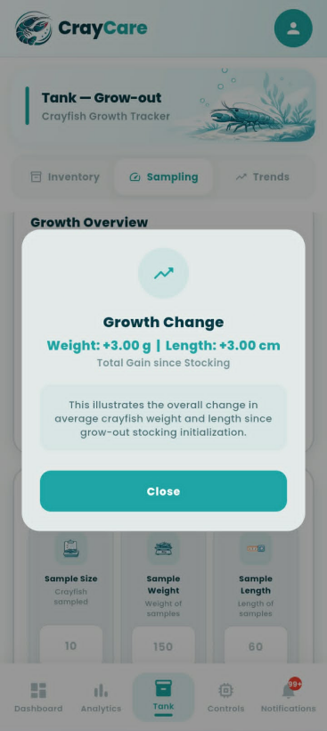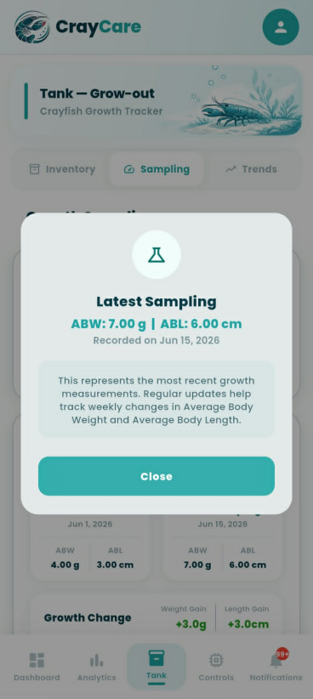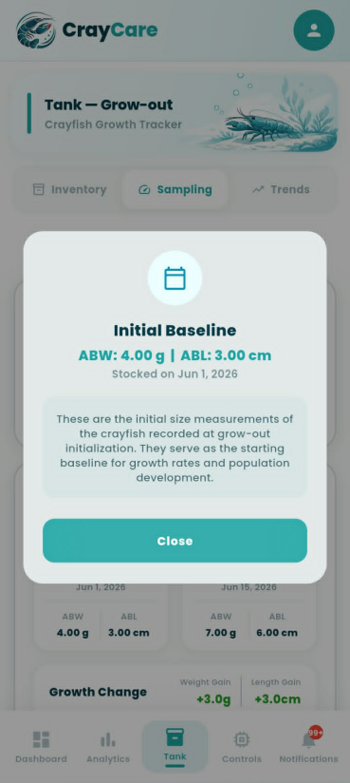

Figure 3.24. Sampling Tab Modal Overlays
Figure 3.24 presents the detailed modal overlays and bottom sheets accessible from the Sampling Tab of the Tank Module. Tapping the "View All" link in the history section launches the "All Sampling History" bottom sheet, providing a dedicated scrollable list of all recorded weekly growth measurements and computed gains. Similarly, selecting any of the cards in the Growth Overview section opens specialized informational modals—specifically for Initial Baseline data, the Latest Sampling parameters, and the total cumulative Growth Change. Each pop-up contains calculated values, contextual explanations regarding starting sizes or cumulative development, and a prominent teal "Close" button to return the user to the main Sampling interface.
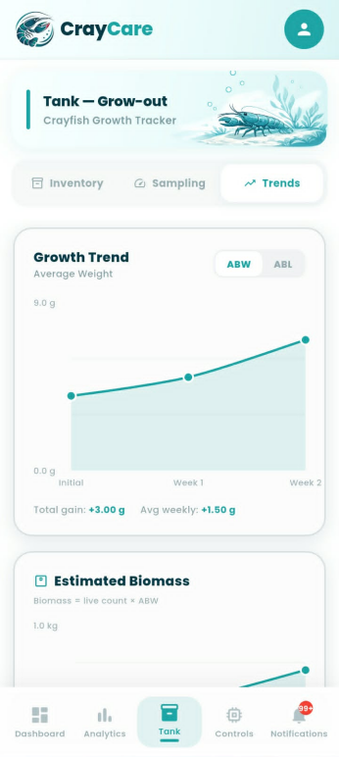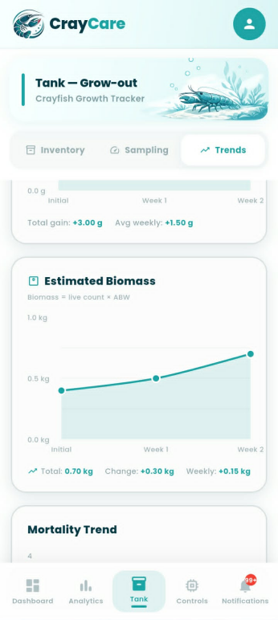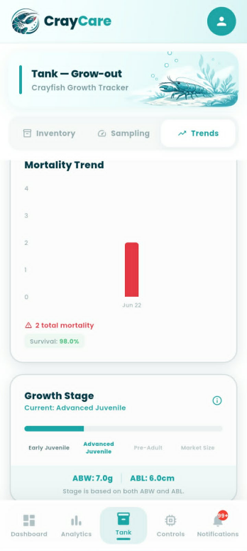
Figure 3.25. Tank Module — Trends Tab
Figure 3.25 presents the Trends Tab of the Tank Module in the CrayCare mobile application, which visualizes key grow-out performance indicators over time. The Growth Trend card features an interactive line graph with a toggle switch to alternate between Average Body Weight (ABW) and Average Body Length (ABL) plots, both detailed with total and average weekly growth summaries. Below this, an Estimated Biomass card plots total computed stock mass, while a Mortality Trend bar chart illustrates historical mortality occurrences alongside overall survival rates. At the bottom of the tab, a segmented Growth Stage progress bar categorizes and displays the crayfish's current developmental classification, such as "Advanced Juvenile," based on the latest physical parameters.
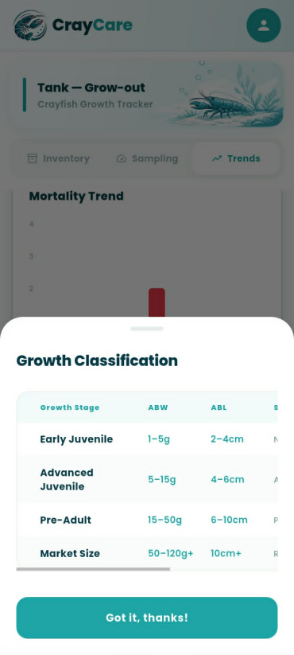
Figure 3.26. Growth Classification Reference Modal
Figure 3.26 presents the Growth Classification Reference Modal of the CrayCare mobile application, which can be accessed by tapping the information icon within the growth stage cards. The modal displays a structured reference table summarizing the classification thresholds for different stages of crayfish development based on Average Body Weight (ABW) and Average Body Length (ABL). The matrix defines four key stages—Early Juvenile, Advanced Juvenile, Pre-Adult, and Market Size—listing their corresponding weight ranges starting from 1g up to 120g+ and length brackets from 2cm to over 10cm. A prominent "Got it, thanks!" button at the bottom of the overlay allows the user to easily dismiss the reference sheet and return to the underlying tab interface.
To support the interpretation of crayfish growth during the experiment, the recorded body measurements will also be compared using the established crayfish size and weight classifications presented below. These classifications will serve as a reference for identifying the developmental stages observed throughout the grow-out period.
Table 3.4
Crayfish Size and Weight Classification Reference
Growth Stage | Average Length (cm) | Average Weight (g) | System Classification
Early Juvenile | 2 – 4 cm | 1 – 5 g | Newly stocked young crayfish
Advanced Juvenile | 4 – 6 cm | 5 – 15 g | Active early growth
Pre-Adult | 6 – 10 cm | 15 – 50 g | Preparing for full maturity
Market Size | > 10 cm | 50 g+ | Ready for harvest
The growth stage classification presented in Table 3.4 was developed based on existing references regarding the growth and stocking size of Red Claw crayfish (Cherax quadricarinatus). The ranges used in this study were not adopted as exact values from a single reference but were established by organizing available growth benchmarks into practical classifications suitable for continuous monitoring of crayfish development.
The Early Juvenile stage was defined based on the minimum stocking size reported by Masser and Rouse (1997), which indicated that crayfish around 1 gram in weight or approximately 1–2 inches in length are suitable for transfer from the nursery phase to grow-out systems. Since the study requires a measurable range for identifying newly stocked crayfish, this reference point was expanded into the classification of 1–5 g and 2–4 cm, representing small juveniles that are still in the early growth phase.
The Advanced Juvenile stage was based on the stocking description provided by Business Queensland (2025), which identifies advanced juveniles as crayfish commonly stocked at approximately 5–10 g. To accommodate natural variation in crayfish growth and provide a wider monitoring range, this study classified Advanced Juveniles as crayfish weighing 5–15 g with a length of 4–6 cm. This stage represents crayfish that have moved beyond initial stocking size and are undergoing active growth.
The Pre-Adult stage was established as an intermediate classification between juvenile development and harvestable size. Literature from the Food and Agriculture Organization (2011) and Masser and Rouse (1997) indicates that Red Claw crayfish continue rapid growth before reaching maturity, with maturity commonly associated with weights around 50 g and above. Based on this growth pattern, the study classified crayfish weighing 15–50 g and measuring 6–10 cm as Pre-Adults, representing individuals approaching mature size but not yet within the target harvest range.
The Market Size stage represents crayfish that have reached a size suitable for harvesting. Business Queensland (2025) reports that crayfish may reach approximately 35–100 g or more within the grow-out period, while Masser and Rouse (1997) reported that Red Claw crayfish can attain 50–100+ g under suitable growing conditions. Based on these reported growth values, this study classified crayfish weighing 50 g and above as Market Size, since this weight range indicates that crayfish have reached a more advanced stage of development and are within the expected harvestable size range. The length classification of greater than 10 cm was used as a corresponding physical indicator of this stage, representing crayfish that have developed beyond the juvenile growth phases and are suitable for harvesting evaluation.
Overall, the growth classifications used in this study were developed by interpreting available size and weight references and converting them into measurable ranges that can be applied during system monitoring. These categories allow the researchers to track changes in crayfish growth, identify developmental stages, and evaluate whether the culture conditions support expected growth progression.
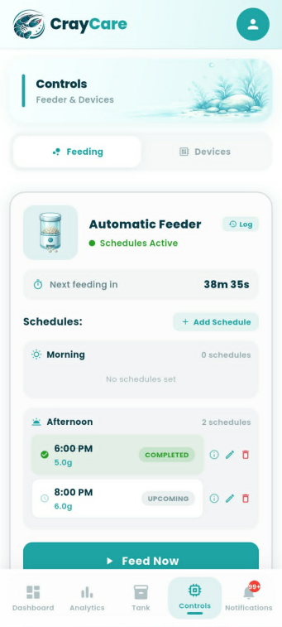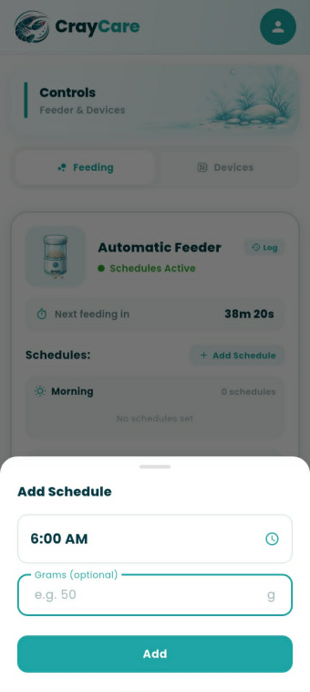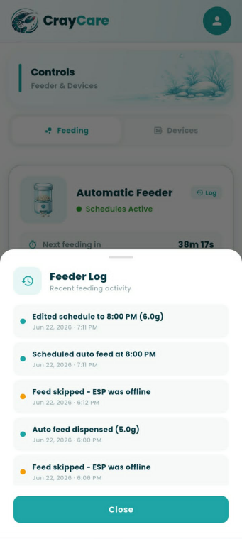
Figure 3.27. Controls Module — Feeding Tab
Figure 3.27 presents the Feeding Tab under the Controls Module of the CrayCare mobile application, which allows the user to manage and schedule automated feeding routines. The interface features a status card showing the remaining countdown until the next feed, a scrollable schedule list divided into Morning and Afternoon sessions with options to edit or delete entries, and a manual "Feed Now" action button. Tapping the "+ Add Schedule" button launches a bottom sheet overlay where users can select a precise feeding time and specify a desired portion weight in grams. Additionally, the "Feeder Log" overlay provides a chronological history of recent feeding activities, detailing successful automated dispenses alongside system skip logs caused by offline hardware warnings.
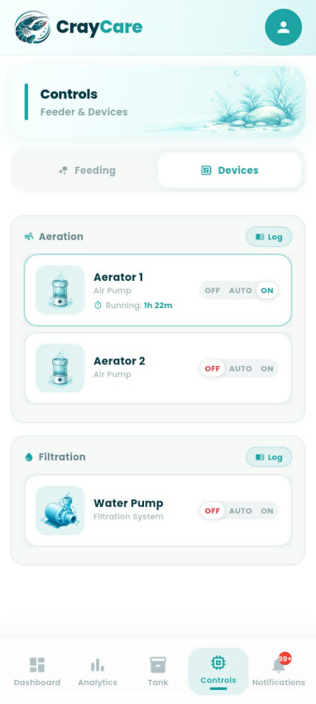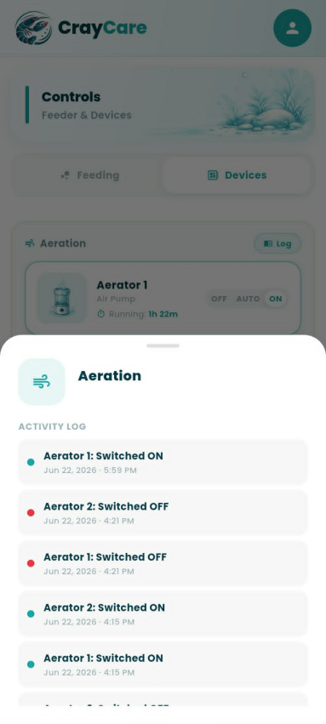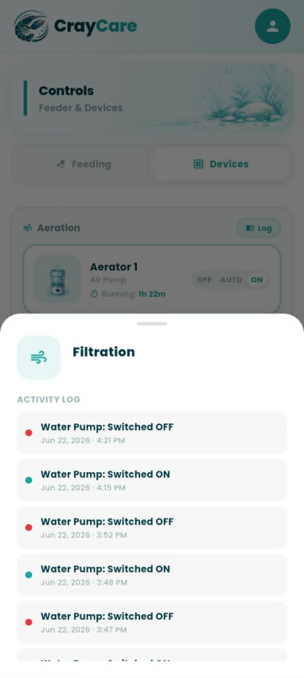

Figure 3.28. Controls Module — Devices Tab
Figure 3.28 presents the Devices Tab under the Controls Module of the CrayCare mobile application, which allows the user to supervise and configure auxiliary hardware systems. The interface organizes the hardware controls into Aeration and Filtration categories, housing dedicated cards for Aerator 1, Aerator 2, and the Water Pump. Each device card features a three-mode toggle selector—offering OFF, AUTO, and ON options—accompanied by real-time status details such as active running durations. Furthermore, tapping the respective "Log" button next to either category header launches a bottom sheet overlay displaying the chronological state-change history for those specific devices.
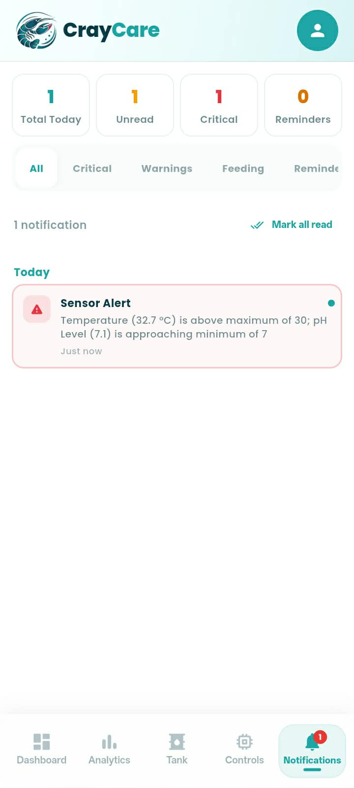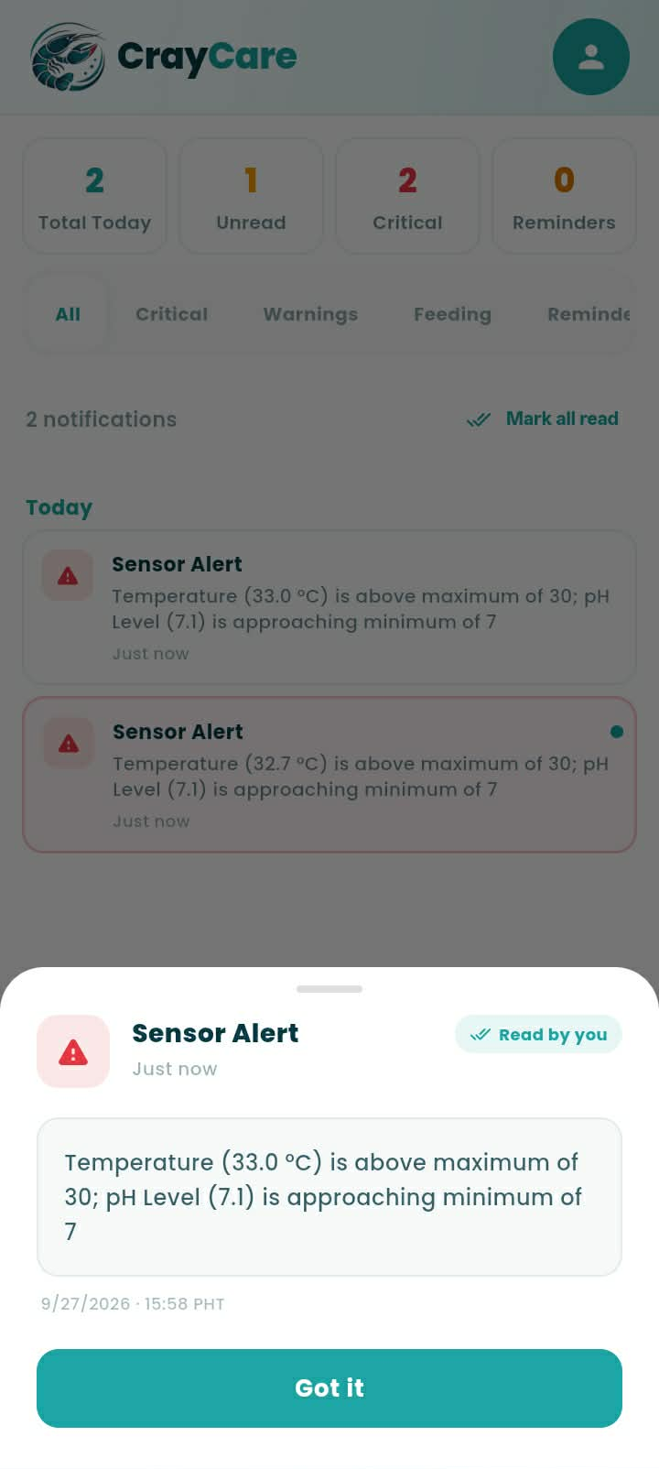
Figure 3.29. Notifications Module
Figure 3.19 presents the Notification Module, where users can review notifications about sensor alerts, feeding outcomes, reminders, and system events. Summary cards show today’s total, unread notifications, critical alerts, and reminders. Category filters help users find specific notifications, while the date-grouped list shows each item’s title, message, time, and unread status. Users can mark all notifications as read or tap one to view its details.
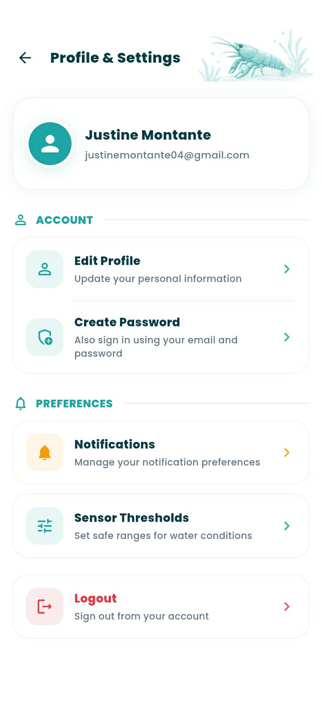
Figure 3.30. Profile & Settings Menu
Figure 3.30 shows the Profile & Settings menu, which provides access to the user’s account information and preferences. The profile card displays the user’s name and email address. Under Account, users can edit their profile information and create a password or change an existing one. Under Preferences, they can manage notification settings and sensor thresholds. A separate Logout option allows users to sign out of their account.
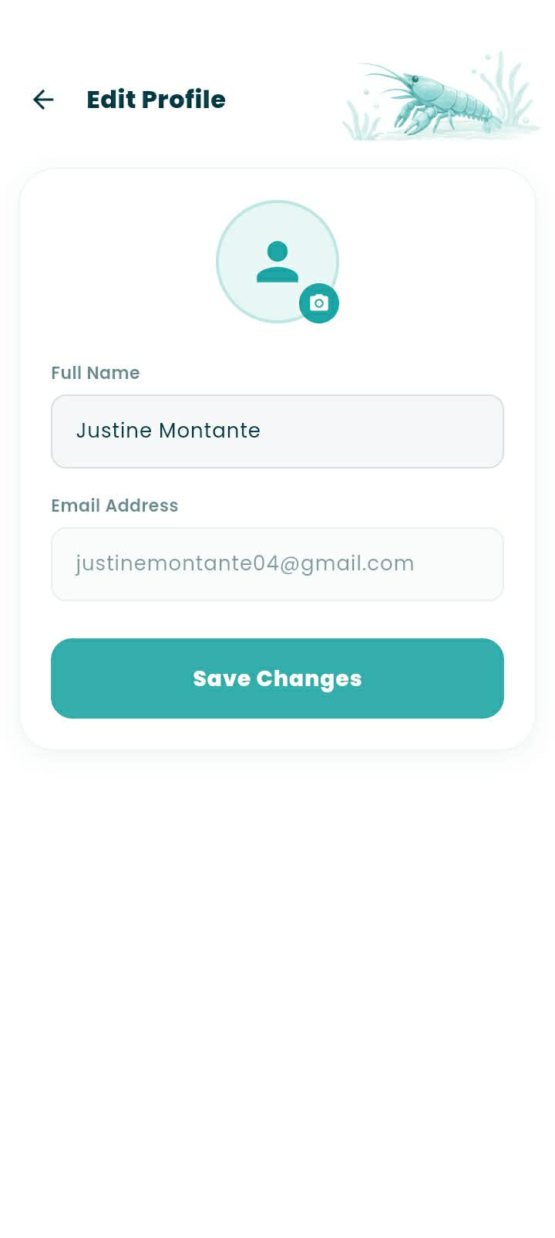
Figure 3.31. Edit Profile Sub-Screen
Figure 3.31 presents the Edit Profile sub-screen, which users can access from the Profile & Settings menu. It allows users to update their display name and profile photo using the camera icon. The registered email address is shown as read-only. After editing their information, users can save the changes to update their profile.
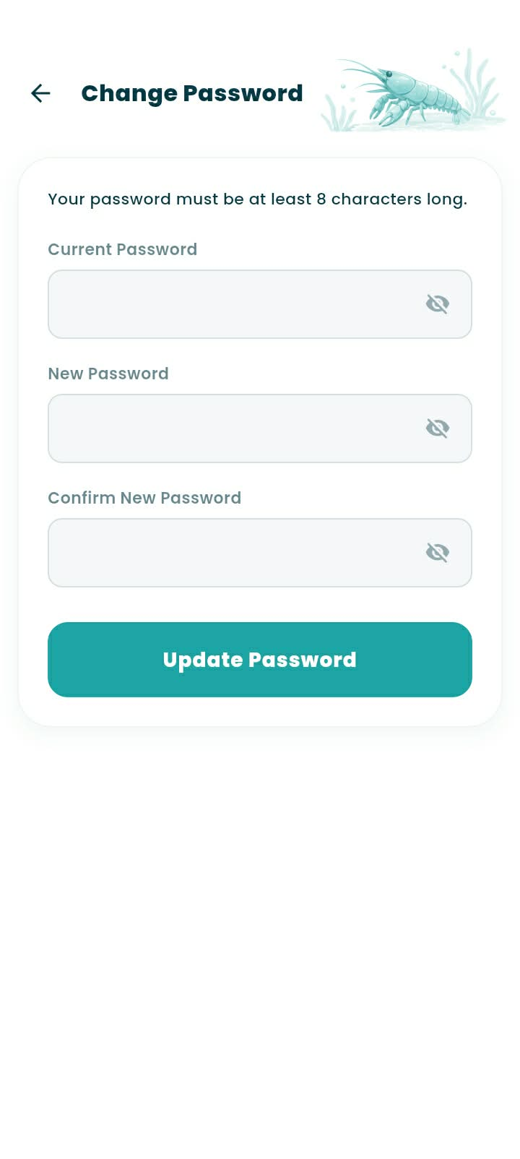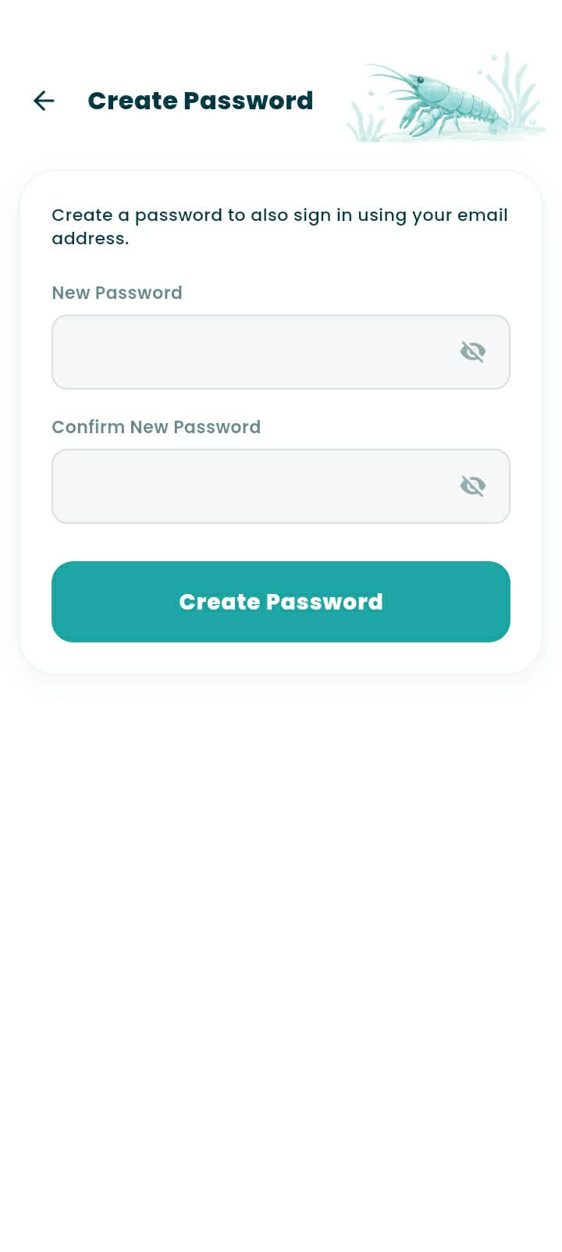
Figure 3.32. Create and Change Password Sub-Screens
Figure 3.32 presents the Create Password and Change Password sub-screens accessible from Profile & Settings. The Create Password screen allows users who signed in with Google to set a password for future email sign-ins by entering and confirming a new password. The Change Password screen is for users with an existing password; it requires the current password, a new password, and confirmation of the new password. Both screens include visibility controls so users can check their entries before submitting.
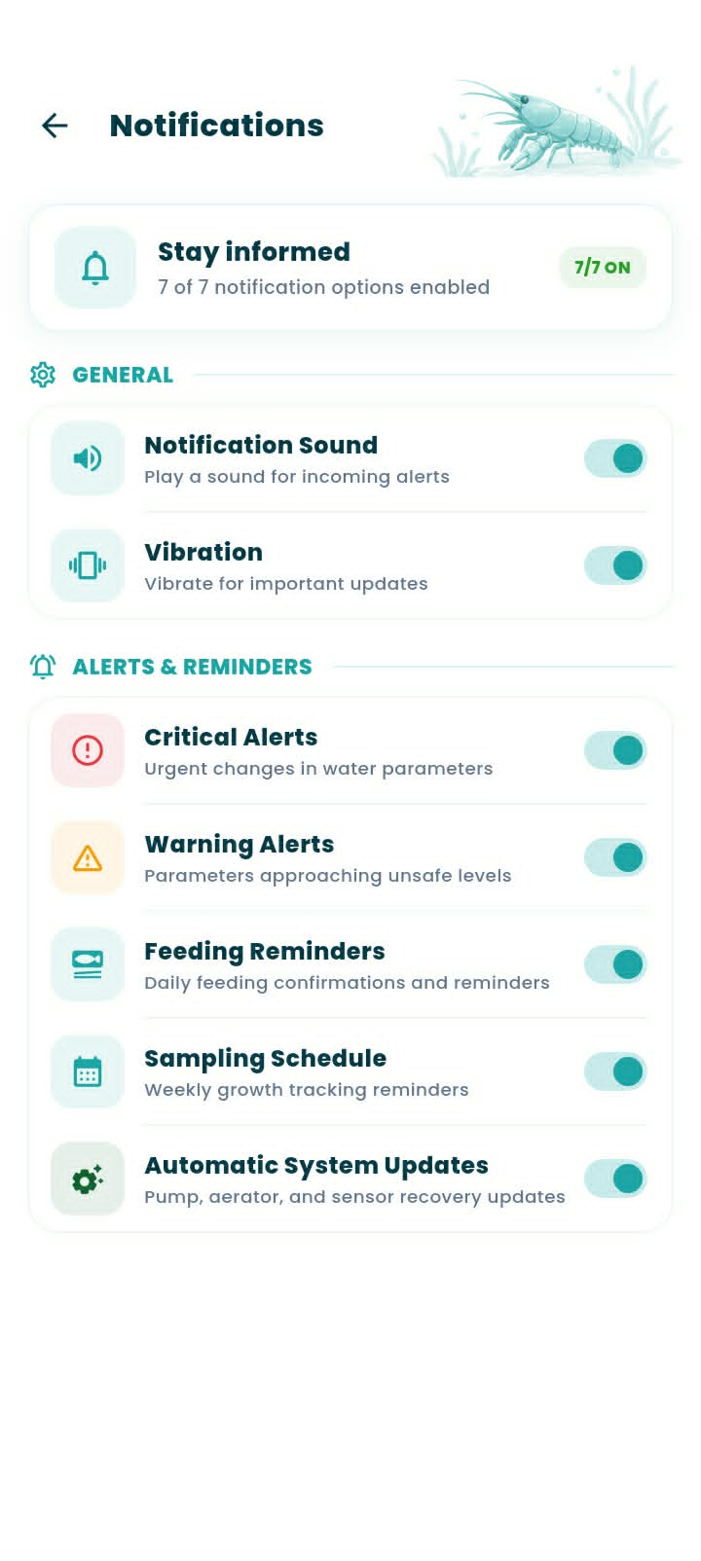
Figure 3.33. Notifications Preferences Sub-Screen
Figure 3.33 shows the notification settings users can customize. The “Stay informed” card summarizes how many options are enabled. Under General, users can turn notification sound and vibration on or off. Under Alerts & Reminders, they can manage Critical Alerts for urgent water-parameter changes, Warning Alerts for readings approaching unsafe levels, Feeding Reminders, weekly Sampling Schedule reminders, and Automatic System Updates for pump, aerator, and sensor-recovery updates.
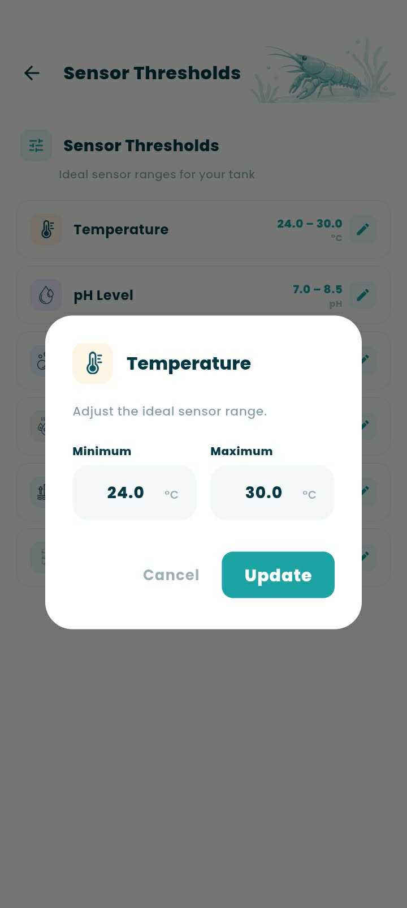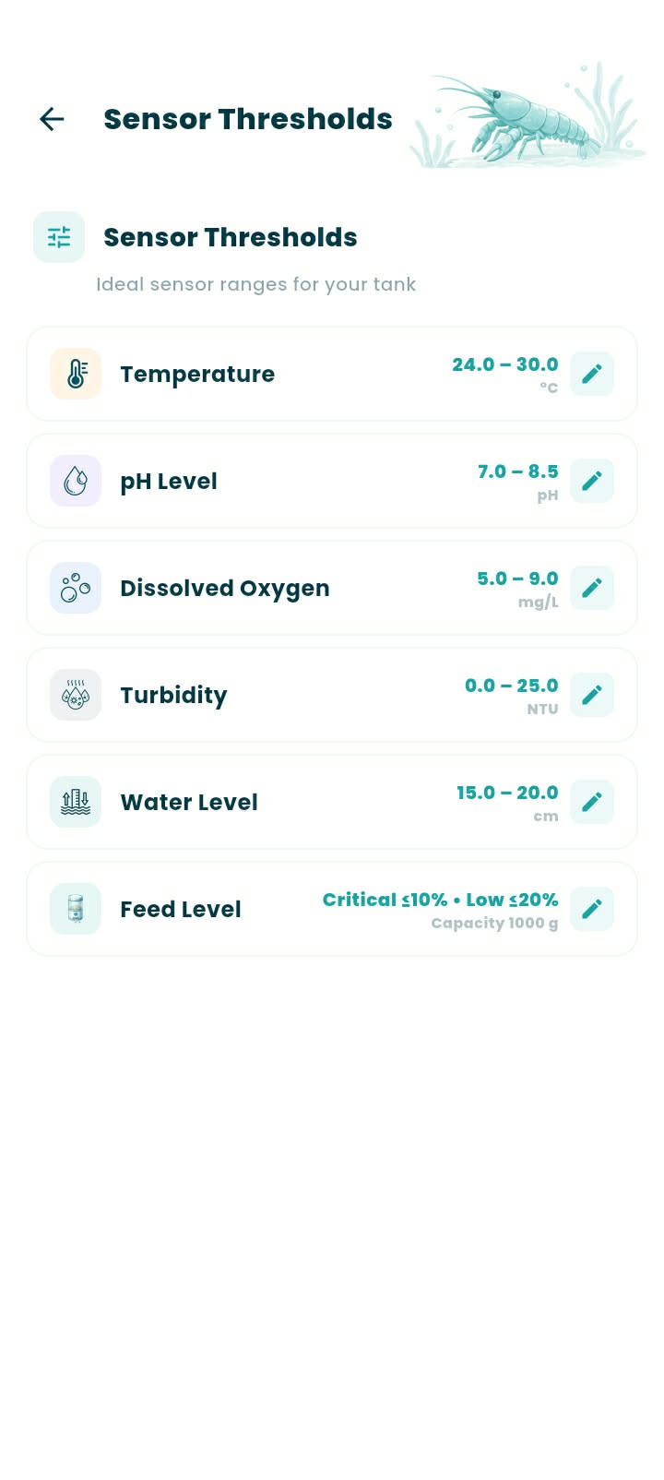
Figure 3.34. Sensor Thresholds Sub-Screen
Figure 3.34 shows the Sensor Thresholds sub-screen, where users can review the configured ranges for Temperature, pH, Dissolved Oxygen, Turbidity, Water Level, and Feed Level. Selecting the edit icon opens a dialog for the chosen parameter. For example, the Temperature dialog lets users adjust the minimum and maximum values, then select Update to save or Cancel to discard the changes. The app validates the entered range before saving it.
Table 3.5. Consolidated Sensor Safe Ranges
Sensor | Optimal Range | Reference
Temperature | 26–29 °C
pH Level | 7.0–8.5
Dissolved Oxygen | Above 5 mg/L
Turbidity | 5-25 NTU
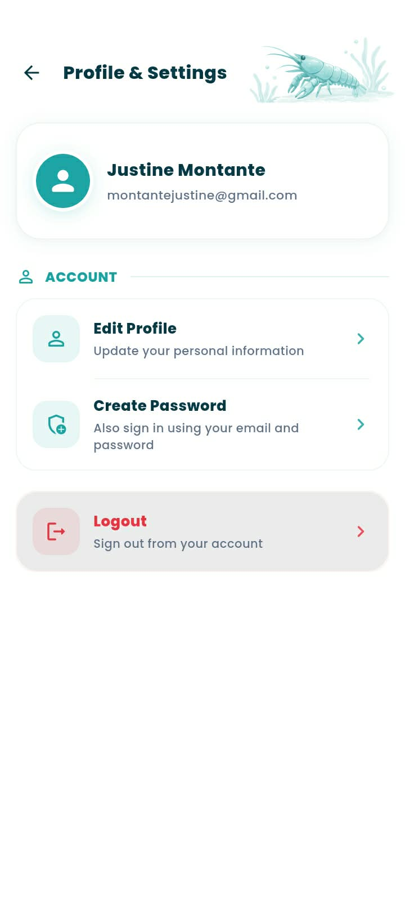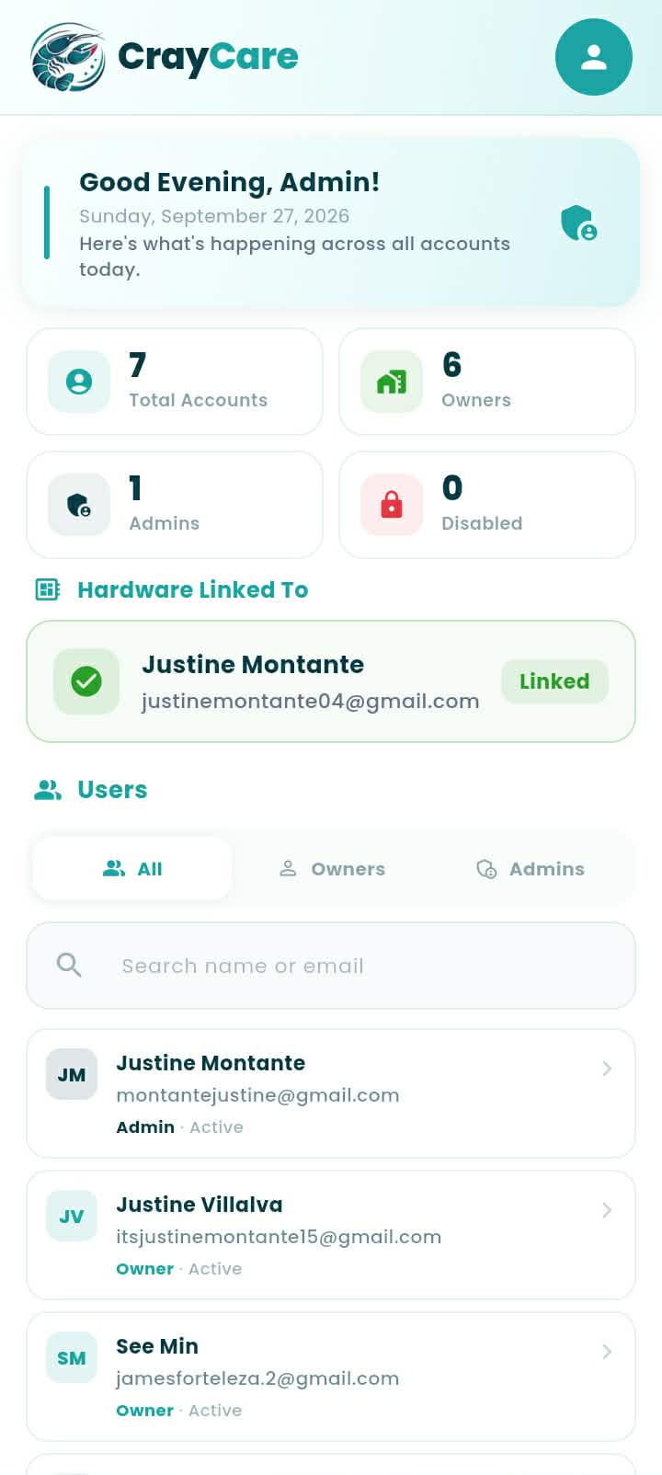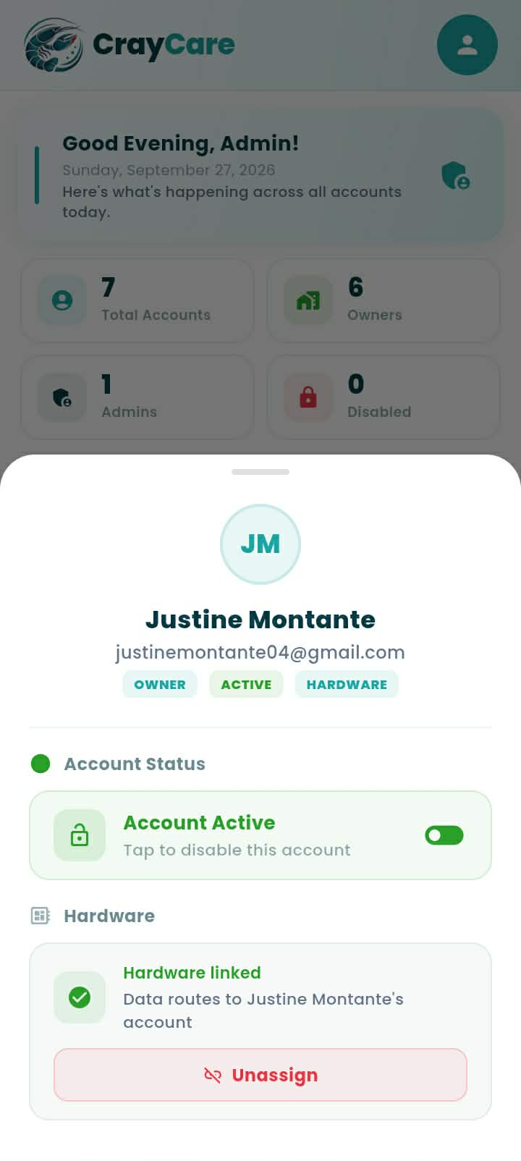
Figure 3.37. Admin Module and Settings Interface
Figure 3.37 presents the Admin Module and Profile & Settings interface of the CrayCare mobile application. The Admin dashboard summarizes the total accounts, owners, admins, and disabled accounts, and shows which owner the hardware is linked to. In the Users section, the administrator can filter accounts by role, search by name or email, and view each user’s role and account status. The administrator can also open an account to manage it, assign hardware to an owner, or disable the account. Profile & Settings provides options to edit the administrator’s profile, create a password, and log out.

